**To do list for climwin V 0.0.2**

General

* ~~Load source code to github.~~

Coding

* Test coxph models.
* **~~Speedup CMatrix build code (remove match() function). URGENT THIS IS CAUSING HUGE SPEED ISSUES. Match function is 2.7x slower than which function.~~**

This is now fixed but only for days, still needs work for weeks and months.

Also needs to be fixed for Xvar2

* Allow use of “I” and “LOG” FUNC when negative values are present.
* ~~When there are NA values and CMISSING = FALSE, we need a print out that tells you which dates are the problem, this can be very hard to debug data~~
* Now returns an object ‘Missing’ that contains all dates where Xvar is NA. However, this can return irrelevant dates that aren’t actually used in the CMatrix.
* ~~Function to output the median climate window for 95% model weights?~~
* Include possibility for parallel processing?
* In crosswin give an option to look at correlation between two different stats (i.e. correlation b/w min rain and mean temperature).
* Growing degree days (“gdd20”), with variable cut off point
* ~~When using “min”:  
  Warning messages:~~

~~1: In windowclose:windowopen :~~

~~numerical expression has 2 elements: only the first used~~

~~2: In windowclose:windowopen :~~

~~numerical expression has 2 elements: only the first used~~

* Delta AICc can get large positive values (e.g. 4+) when you have more parameters in your model (see below).

**IS THIS A MIXED MODEL ISSUE?!**

**If so, we need to ensure that we include random effects models/covariate models in our code testing**

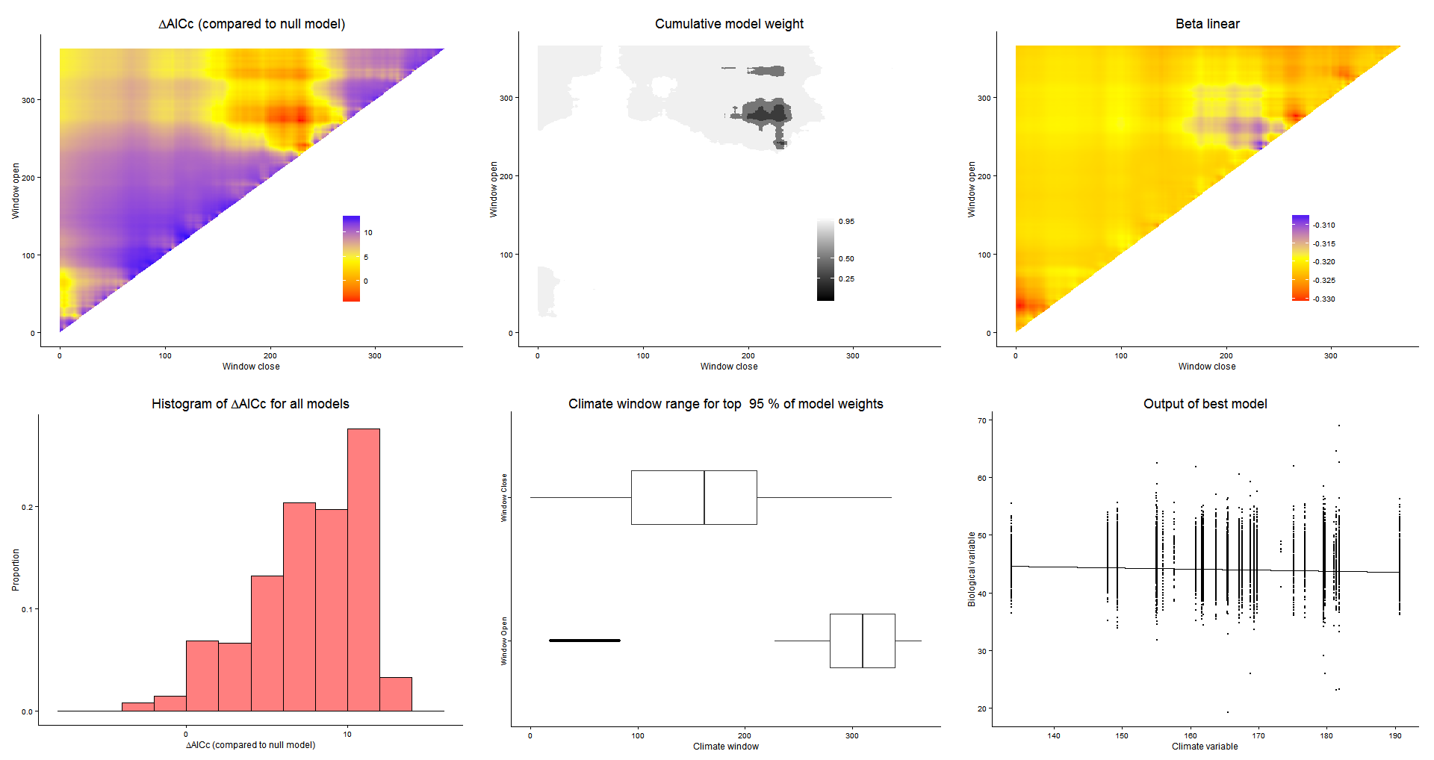

Plotting

* Best plot uses mean values when plotting large datasets?
* Print median climate window values from boxplots.
* Put a large title on the facet plot so we know which plot is for which model?